**🧠 Task 3: Docker Compose for Multi-Environment**

**Name:** Ujjawal Rawat  
**Date:** *5/10/2025*  
**Task Title:** Docker Compose for Multi-Environment (Nginx + Watchtower)

**🎯 Objective**

The objective of this task is to use **Docker Compose** to create and manage a **multi-container environment** that includes:

* **Nginx** for serving a static website.
* **Watchtower** for automatic container updates.

This demonstrates container orchestration using Docker Compose in a simple, production-style setup.

**⚙️ Project Overview**

This project defines a multi-service setup using a single docker-compose.yml file.  
It runs:

1. **Nginx container** → hosts static HTML files.
2. **Watchtower container** → automatically updates Docker containers when new image versions are available.

This setup represents a **multi-environment ready structure** (e.g., development, testing, production).

**🧱 Project Structure**

docker-multi-env/

├── docker-compose.yml

└── html/

└── index.html

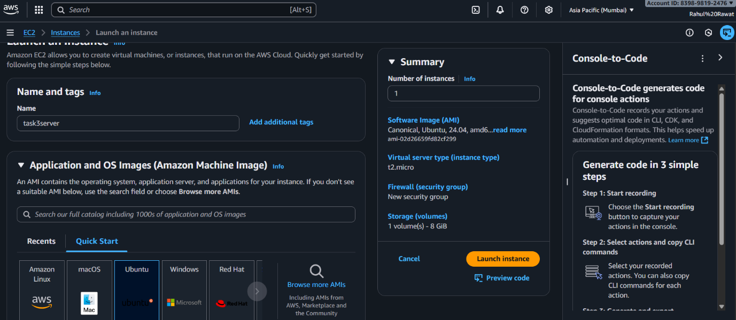

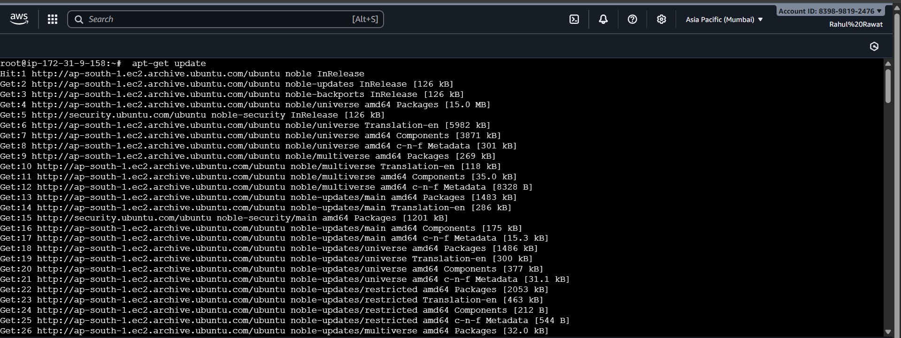

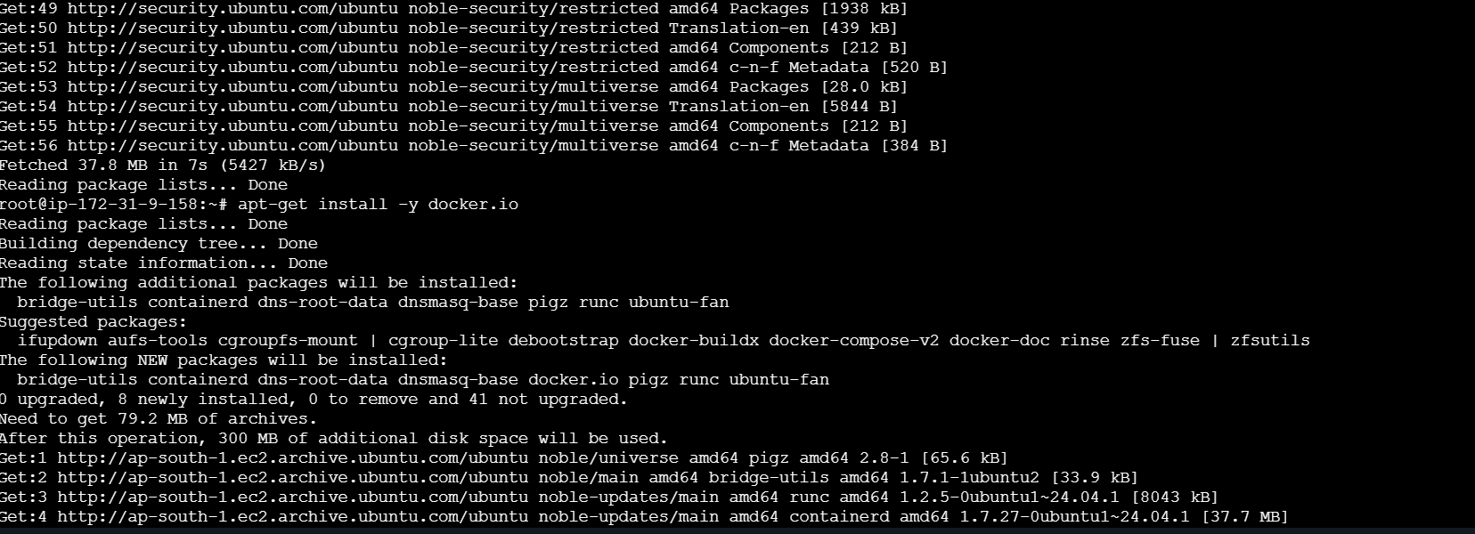

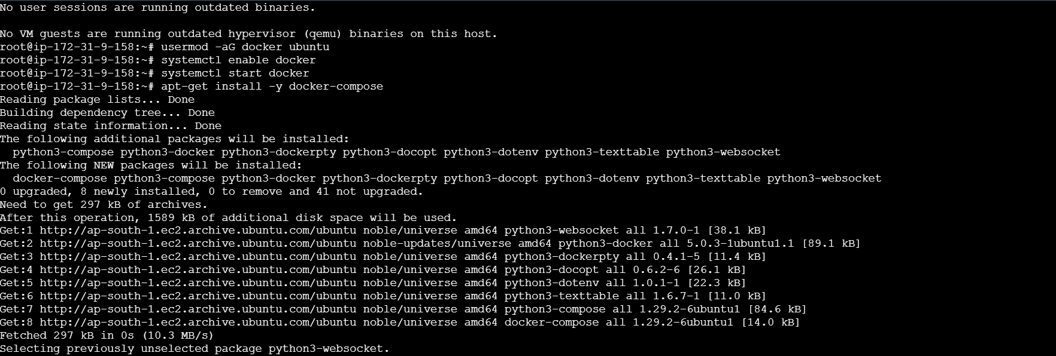

**🐳 Docker Compose File**

version: '3.8'

services:

nginx:

image: nginx:latest

container_name: nginx_static

ports:

- "80:80"

volumes:

- ./html:/usr/share/nginx/html:ro

restart: always

watchtower:

image: containrrr/watchtower

container_name: watchtower

volumes:

- /var/run/docker.sock:/var/run/docker.sock

environment:

- WATCHTOWER_CLEANUP=true

- WATCHTOWER_POLL_INTERVAL=30

restart: always

**🪜 Steps Followed**

**Create project directory**

mkdir project

cd project

**Create docker-compose.yml**

**vim docker-compose.yml**

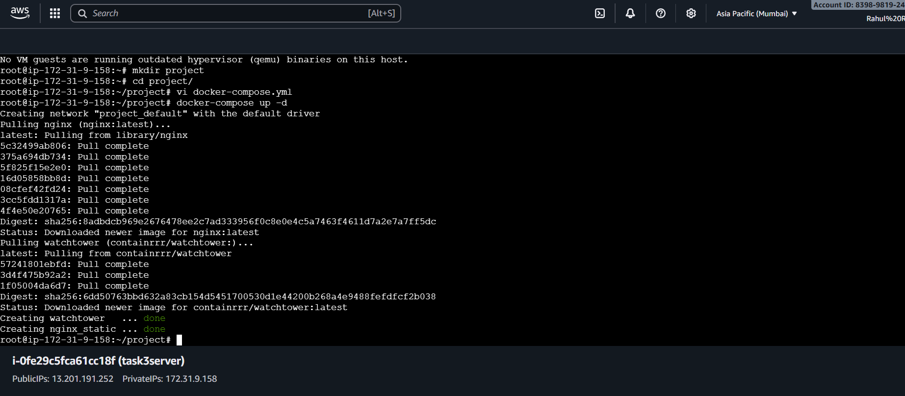

**4️⃣ Run the containers**

docker-compose up -d

**5️⃣ Verify running containers**

docker ps

You should see **nginx_static** and **watchtower** running.



\

**6️⃣ Test in browser**

Go to 👉 [**http://localhost**](http://localhost)  
Output:

“Hello from Nginx + Docker Compose!”

**7️⃣ Stop containers**

docker-compose down

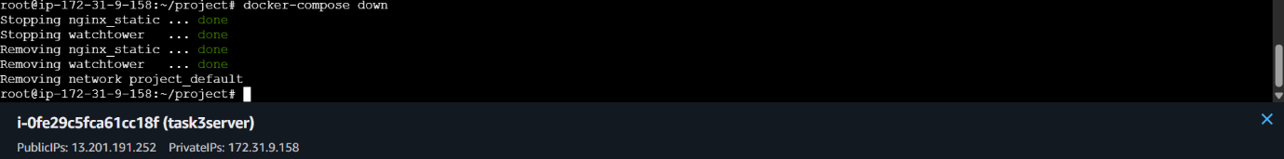

**🌐 Outcome**

✅ Successfully created a **Docker Compose setup** running:

* **Nginx** for serving static web content.
* **Watchtower** for automated updates.

The project demonstrates **container automation and multi-service orchestration** using Docker Compose.

**🏁 Conclusion**

This task successfully showcased how Docker Compose simplifies the management of multiple containers.  
It provided a hands-on understanding of deployment automation and environment consistency across development and production setups.